ABU LIBRARY COMPLEX BULLETIN
MONTHLY BULLETIN VOLUME: Vol. 3 No. 2 WEDBESDAY, 5TH MAY 2015

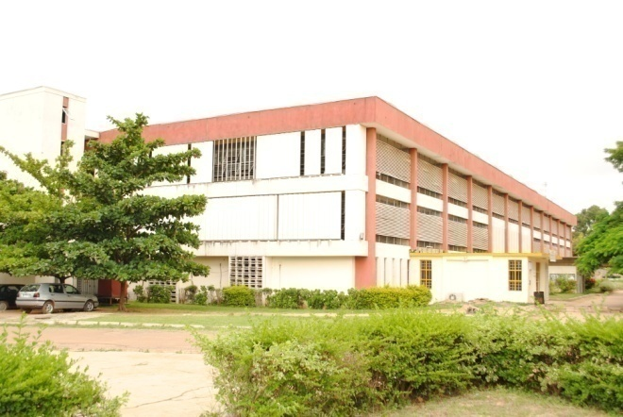
GETTING ACQUINTED WITH THE ABU LIBRARY COMPLEX SERIES 3
This is the 3rd in the series “Getting acquainted with ABU Library Complex.” Our focus is on Customer Services Division (CSD), Kashim Ibrahim Library.
CUSTOMER SERVICES DIVISION
Customer Service at Kashim Ibrahim Library is a main function of Ahmadu Bello University Library Complex’s service to its diverse population. The Library Customer Services Division is responsible for all front-line customer interactions across all the University’s libraries.
Kashim Ibrahim Library uses all the standard variables as allowed by library practice, to provide human and material resources. The Customer Services Division, is the LINK between such resources and the targeted users i.e. customers.
In order to facilitate these functions to our various customers, the Division is split into three (3) distinct units:-
- SERVICE DELIVERY UNIT:- This Unit is charged with, (a) REGISTRATION - We register new customers here. Once registered, the customer is allowed to borrow books to use at his/her convenience. This registration is open to all bonafide students, postgraduate students and university staff. Requirement for registration is letter of admission/letter of appointment. (b) CLEARANCE – In the event that a customer is disengaging from the university, as graduating students or retiring staff, we authenticate their clearance forms after verification of our records on behalf of the library. (c) CIRCULATION: (1) to borrow books to read at customer’s convenience, the appropriate place to go is this section of the

Service Delivery Unit. The procedure is simple and time saving because this service has been computerized. (d) OTHER DUTIES – (1) RESERVATION OF REQUEST – should a customer desire to use a book and the book is out on loan, such a customer can place a reservation request. No other customer shall have access to the reserved book whenever the book is charged in. (2) WEEDING AND DISCHARGING – This is done periodically using the under listed criteria: poor physical condition of the book; un-used book for between 10 – 15 years; and outdated publication etc. (3) AMNESTY PERIOD – This is a period that allows defaulters i.e. customers who have overdue books return them for free – no fines.
- SHELF MAINTENANCE UNIT: This Unit makes information resources available to customers. The resources are arranged on the shelves for consultation. It is an open access allowing customers the choice of what they want to consult (free accessibility). It is important to note that the reading resources are arranged discipline by discipline, housed in three (3) areas namely:-
- 1st floor of the main building A – H (Arts and Social Sciences).
- 1st floor of the main building J – P (Arts and Social Sciences).
- 2nd floor of the main building Q – Z (Science, technology and Library Science).
There are competent staff to ‘direct’ you to the shelf/shelves housing your request.
IMPORTANT GUIDES TO HELP YOU/US
- While searching for your choice of books, should you pull out any book/books, do not shelve it/them. Please leave it/them on the reading table for our trained staff to re-shelf it/them appropriately.
- Books consulted for reading, reference, or making notes should be left on the reading table.
- If a customer is interested in doing further reading on any books, he/she is allowed to borrow such books for some period of time (as explained above). Simply take the books to the Service Delivery Unit on the ground floor where the loan is facilitated.
- RESERVE BOOK UNIT
The books housed here are under closed access. They are books that are, generally, on high demand.
GENERAL RULES
- Readers are not allowed into the Reserve Book Unit with any other books/materials, except their note books.
- Readers should be equipped with three (3) facts before putting forward their request to the staff:
- Know the author of the book
- Know the title of the book
- Know the class mark of the book

GENERAL REGULATIONS:
During interactions with library staff, customers can expect to:
- Be acknowledged appropriately
- Be treated courteously and respectfully
- Be valued for their input
- Receive the same high standard of service regardless of age, race, ethnicity, religion, gender, physical limitations, or any other criteria
- Receive prompt and timely service
- Receive knowledgeable service and professionalism from all staff
- Have open access to traditional and innovative resources and instruction in their use
- Have their privacy and confidentiality respected, and
- Have responsive, community-oriented service
ABOUT THE HEAD OF CSD
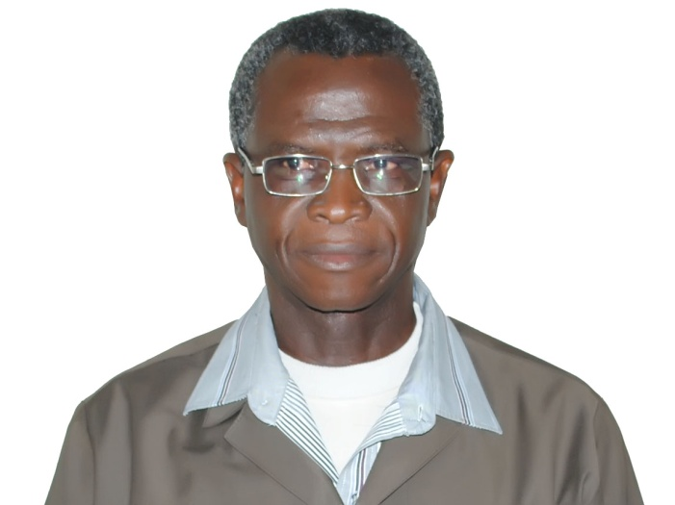
MR. J. A. OCHU
Mr. J. A. Ochu is the Head of CSD. He is one of the old generation of library staff. He is amongst the outstanding professional and practicing (practical) Librarians produced by the Kashim Ibrahim Library Complex. His experiences are viewed against the background of his sojourn within the library complex. He has either worked in or headed important Divisions of the Library: Resource Development Division; Resource Processing Division; Research and Bibliographic Services Division and, currently, Customer Services Division. He left his mark at Division of Agricultural Colleges, when as the Divisional Librarian; his tenure saw the building of new functional Library. Mr. Ochu is an exemplary practicing librarian. He is an exceptional customer friendly and a meticulous Librarian.
STAFF OF THE MONTH
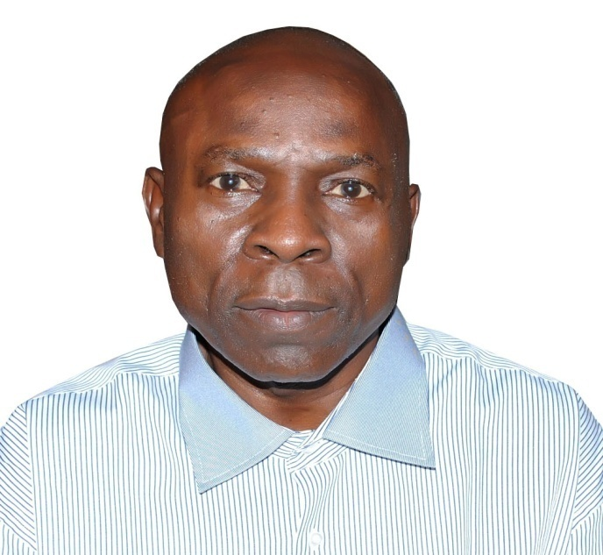
MR. PAUL J. UDUEHI
Assist. Chief Library Officer
He is one of CSD experienced staff. Mr. Paul is customer friendly and he is exceptionally knowledgeable about our resources and their location.
This month (like any other time), Mr. Paul J. Uduehi has been consistently punctual, absolutely devoted to his duty and amiably disposed to customers’ inquiries and assistance. He has been outstanding in his (library) duties.

GREAT: Customer Service Guidelines
These guidelines reflect the Library’s core values and are meant to be carried out within the framework of all customer interactions.
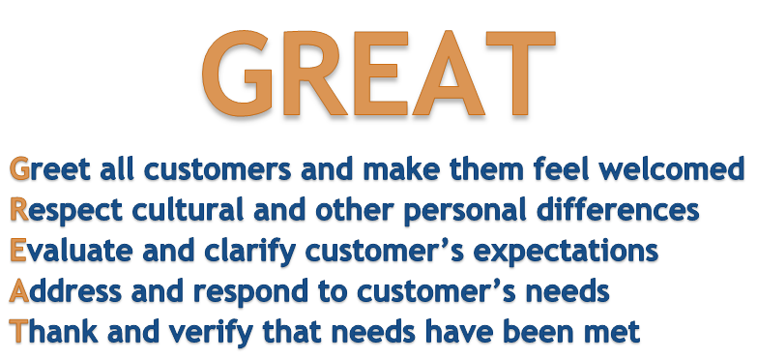
Media & Public Relations Division, KIL – Here to serve you www.abu.edu.ng/library

